Таблицы

Detail

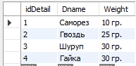

Provider

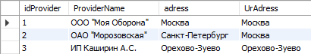

Price

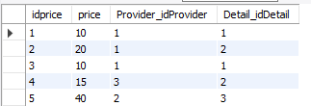

Content

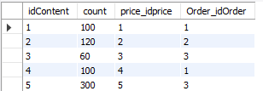

Order1

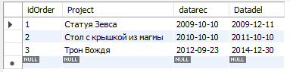

Задание №1

SELECT o.project, o.datadel from detail d

join price p on d.idDetail = p.Detail_idDetail

join content c on p.idprice = c.price_idprice

join order1 o on c.Order_idOrder = o.idorder

where d.dname = 'Саморез'



Задание №2

SELECT o.project, max(o.datarec) from detail d

join price p on d.idDetail = p.Detail_idDetail

join content c on p.idprice = c.price_idprice

join order1 o on c.Order_idOrder = o.idorder

where d.dname = 'Саморез'



Задание №3

-

Схема БД

